Group Problem Set 14: Forces at Angles Check In

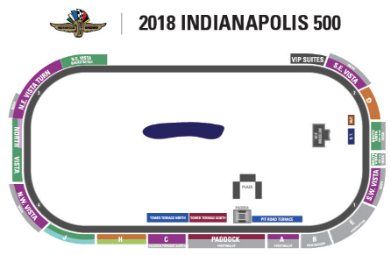
Problem 1. The Indianapolis Motor Speedway has four turns, each consisting of quarter of a circle with a radius of 250 m. The road is banked 10 degrees to help keep the car on the track. An Indy car can enter turn 1 and travel at top speeds of 380 km/h. A full scale IndyCar, including engine, has a mass of ~750 kg.
- Using the diagram, assign the forces on the car as it goes through a turn, assuming the car is traveling at top velocity and experiences no slipping. (The car is driving into the paper).
- What is the coefficient of friction experienced by the car’s tires on the road when it drives through the turn.
- On wet roads, the coefficient of friction can drop by as much as 90%. What is the max velocity possible of the car to drive through the curve with no slipping in a rain storm?
- Now look at the force due to centripetal acceleration. What is the centripetal acceleration at top speed and in a rainstorm? What is the corresponding force? How does the decreased force correspond to max possible force? (report in percent). Is there a linear relationship between velocity, centripetal acceleration and force?
Car
M₂

